Read Me

For running the game, we have pasted the sounds in the project directory folder. You need to link a library for running the game. The procedure is given below:

Go to the properties of the project.

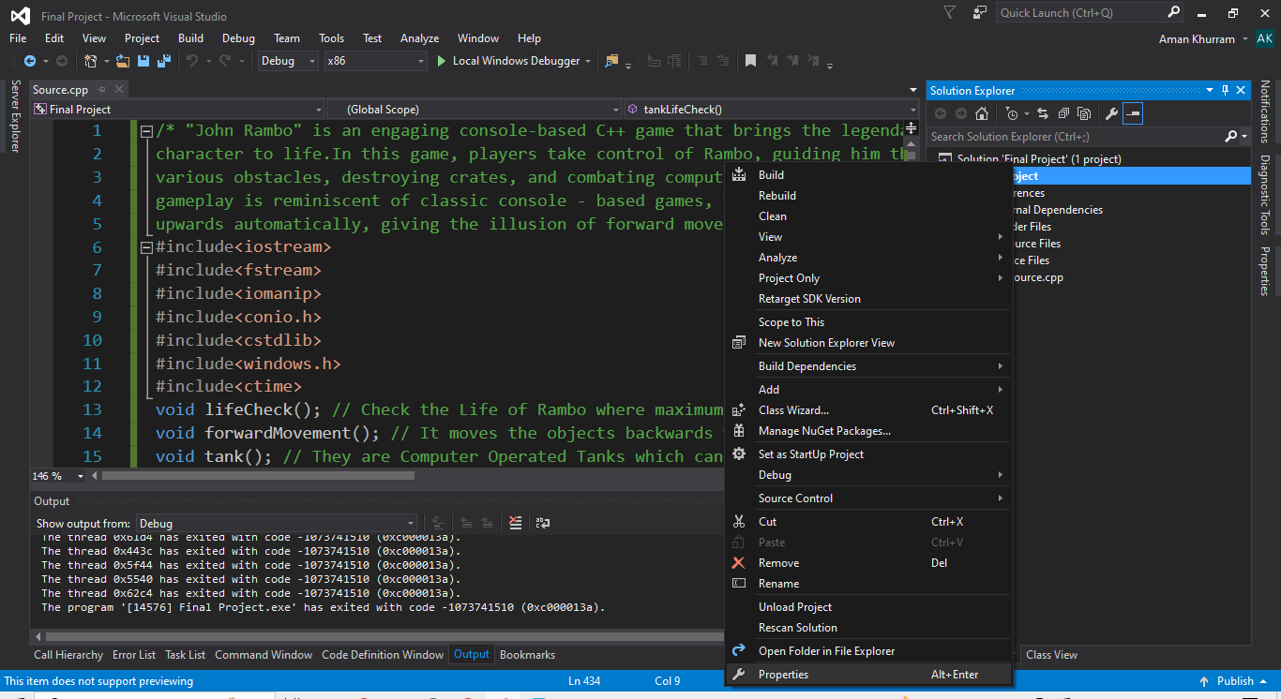

Then click on the linker.

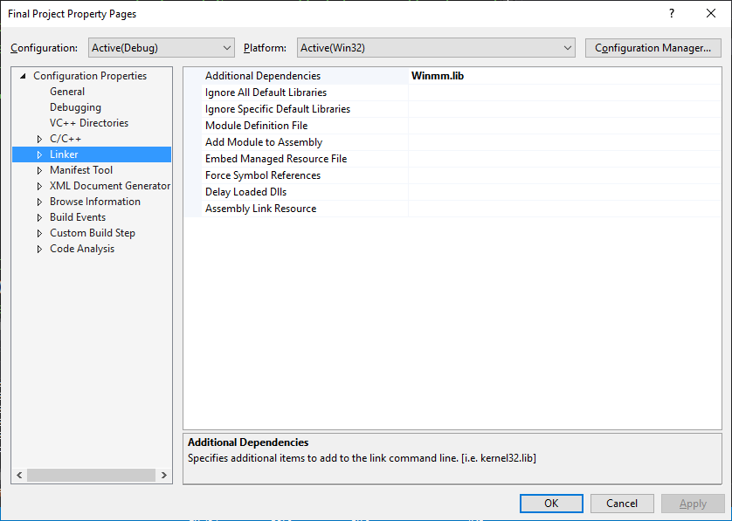

Then click on the input.

If there is some written like this,

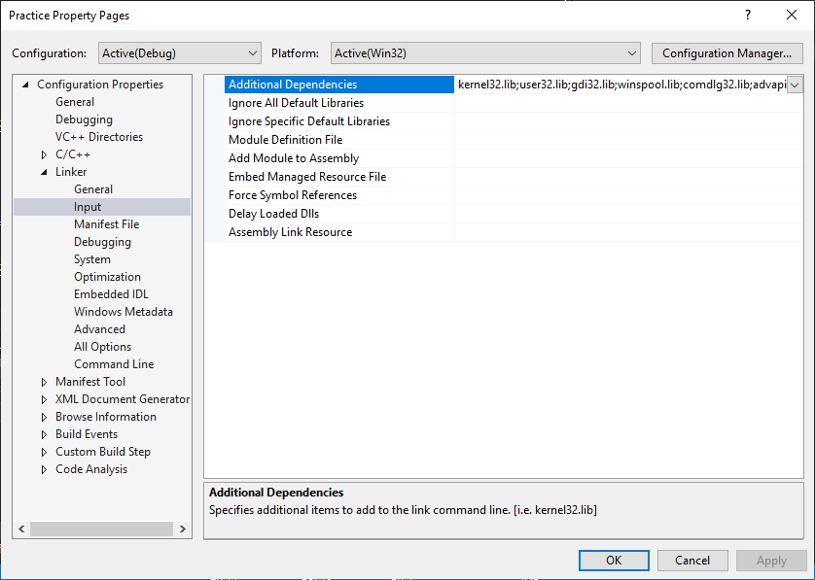

Then, remove it all and write Winmm.lib

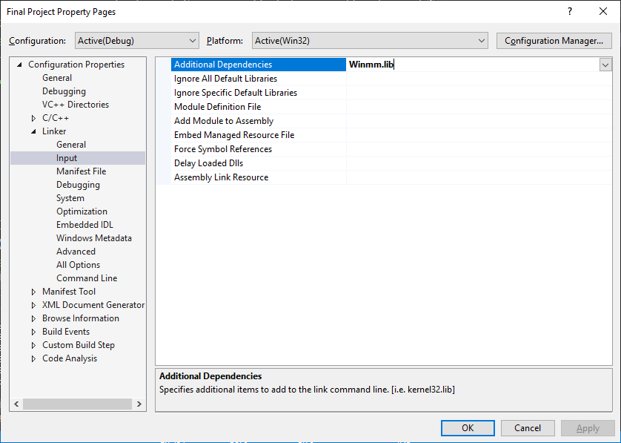

If you open .cpp source files, instead of project folder, then the sounds are given in it.

Without them game will not run. Thank You!